Google Cloud Pub/Sub: Qwik Start - Console

30 minutesFree

Rate Lab

**GSP096**



**Overview**

Google Cloud Pub/Sub is a messaging service for exchanging event data among applications and services. A producer of data publishes messages to a Cloud Pub/Sub topic. A consumer creates a subscription to that topic. Subscribers either pull messages from a subscription or are configured as webhooks for push subscriptions. Every subscriber must acknowledge each message within a configurable window of time.

What you'll do

* Set up a topic to hold data.
* Subscribe to a topic to access the data.
* Publish and then consume messages with a pull subscriber.

**Setup and Requirements**

Qwiklabs setup

**Before you click the Start Lab button**

Read these instructions. Labs are timed and you cannot pause them. The timer, which starts when you click **Start Lab**, shows how long Google Cloud resources will be made available to you.

This Qwiklabs hands-on lab lets you do the lab activities yourself in a real cloud environment, not in a simulation or demo environment. It does so by giving you new, temporary credentials that you use to sign in and access Google Cloud for the duration of the lab.

**What you need**

To complete this lab, you need:

* Access to a standard internet browser (Chrome browser recommended).
* Time to complete the lab.

**Note:** If you already have your own personal Google Cloud account or project, do not use it for this lab.

**Note:** If you are using a Pixelbook, open an Incognito window to run this lab.

Now that you've started your lab, you'll log in to the Google Cloud Shell console, then launch the command line tool.

**How to start your lab and sign in to the Google Cloud Console**

1. Click the **Start Lab** button. If you need to pay for the lab, a pop-up opens for you to select your payment method. On the left is a panel populated with the temporary credentials that you must use for this lab.

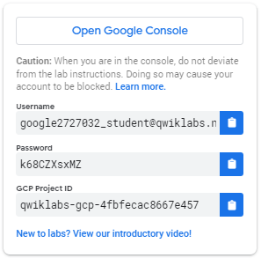

1. Copy the username, and then click **Open Google Console**. The lab spins up resources, and then opens another tab that shows the **Sign in** page.

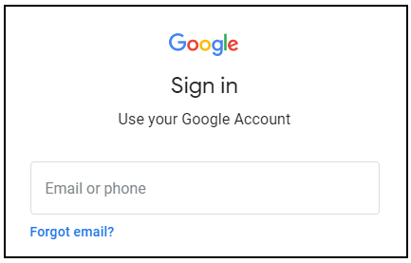

***Tip:*** Open the tabs in separate windows, side-by-side.

If you see the **Choose an account** page, click **Use Another Account**. 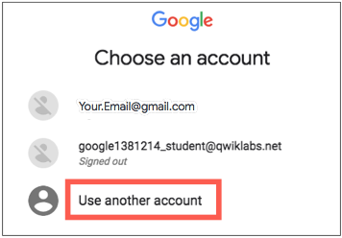

1. In the **Sign in** page, paste the username that you copied from the Connection Details panel. Then copy and paste the password.

***Important:*** You must use the credentials from the Connection Details panel. Do not use your Qwiklabs credentials. If you have your own Google Cloud account, do not use it for this lab (avoids incurring charges).

1. Click through the subsequent pages:
   * Accept the terms and conditions.
   * Do not add recovery options or two-factor authentication (because this is a temporary account).
   * Do not sign up for free trials.

After a few moments, the Cloud Console opens in this tab.

**Note:** You can view the menu with a list of Google Cloud Products and Services by clicking the **Navigation menu** at the top-left. 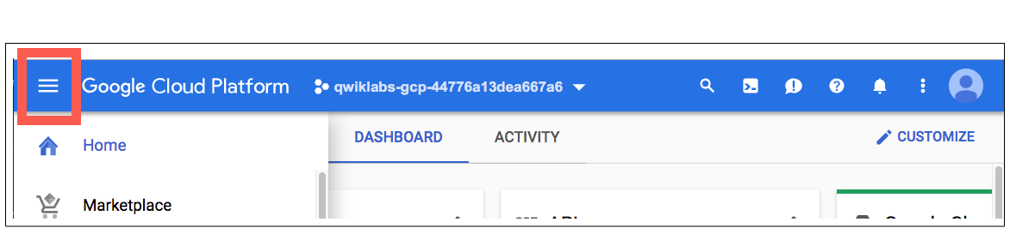

Activate Cloud Shell

Cloud Shell is a virtual machine that is loaded with development tools. It offers a persistent 5GB home directory and runs on the Google Cloud. Cloud Shell provides command-line access to your Google Cloud resources.

In the Cloud Console, in the top right toolbar, click the **Activate Cloud Shell** button.

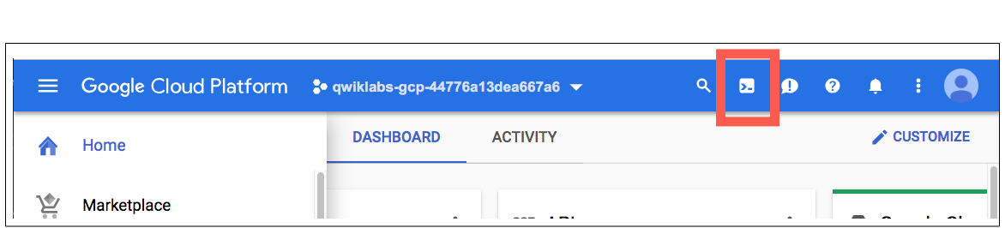

Click **Continue**.

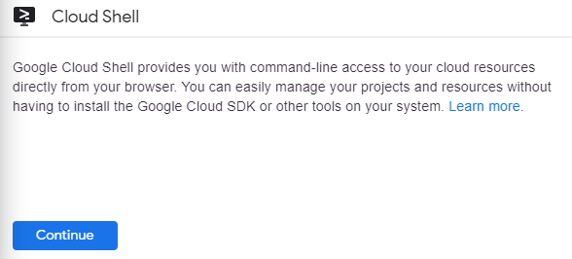

It takes a few moments to provision and connect to the environment. When you are connected, you are already authenticated, and the project is set to your *PROJECT\_ID*. For example:

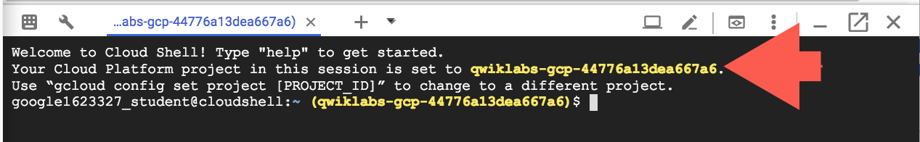

gcloud is the command-line tool for Google Cloud. It comes pre-installed on Cloud Shell and supports tab-completion.

You can list the active account name with this command:

gcloud auth list

(Output)

Credentialed accounts:

- <myaccount>@<mydomain>.com (active)

(Example output)

Credentialed accounts:

- google1623327\_student@qwiklabs.net

You can list the project ID with this command:

gcloud config list project

(Output)

[core]

project = <project\_ID>

(Example output)

[core]

project = qwiklabs-gcp-44776a13dea667a6

For full documentation of gcloud see the [gcloud command-line tool overview](https://cloud.google.com/sdk/gcloud" \t "_blank).

**Setting up Pub/Sub**

You can use the Google Cloud Shell console to perform operations in Google Cloud Pub/Sub.

To use a Pub/Sub, you create a topic to hold data and a subscription to access data .published to the topic.

1. Click **Navigation menu** > **Pub/Sub** > **Topics**.

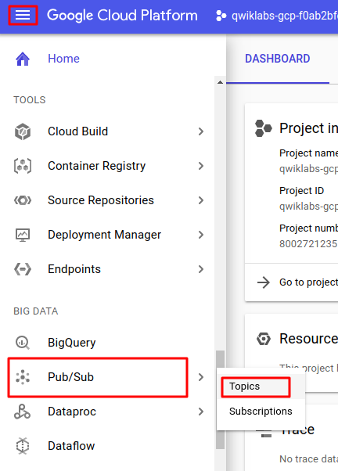

1. Click **Create a topic**.

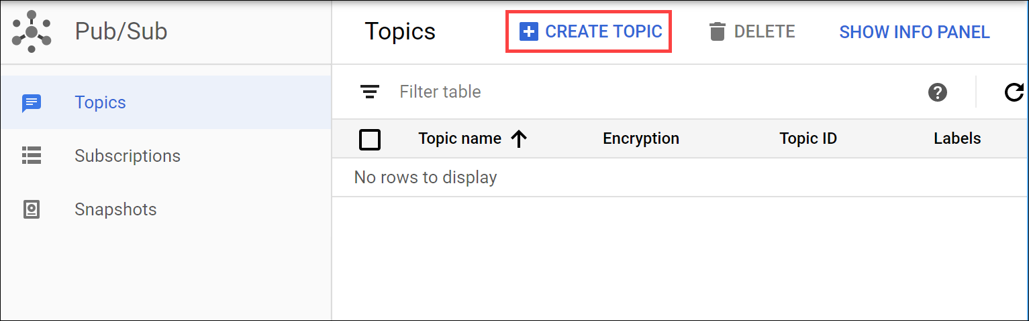

1. The topic must have a unique name. For this lab, name your topic MyTopic. In the **Create a topic** dialog:

* **Name** your topic MyTopic.
* Leave **Encryption** at the default value.
* Click **CREATE TOPIC**.

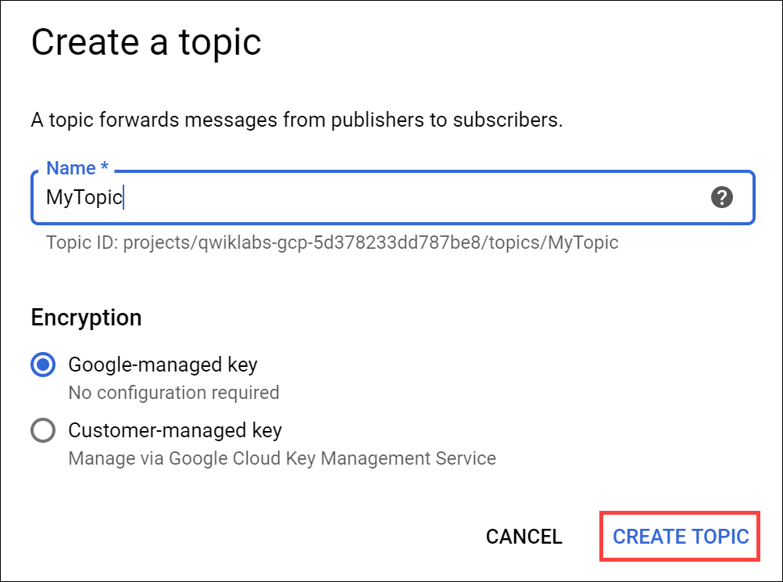

You've created a topic.

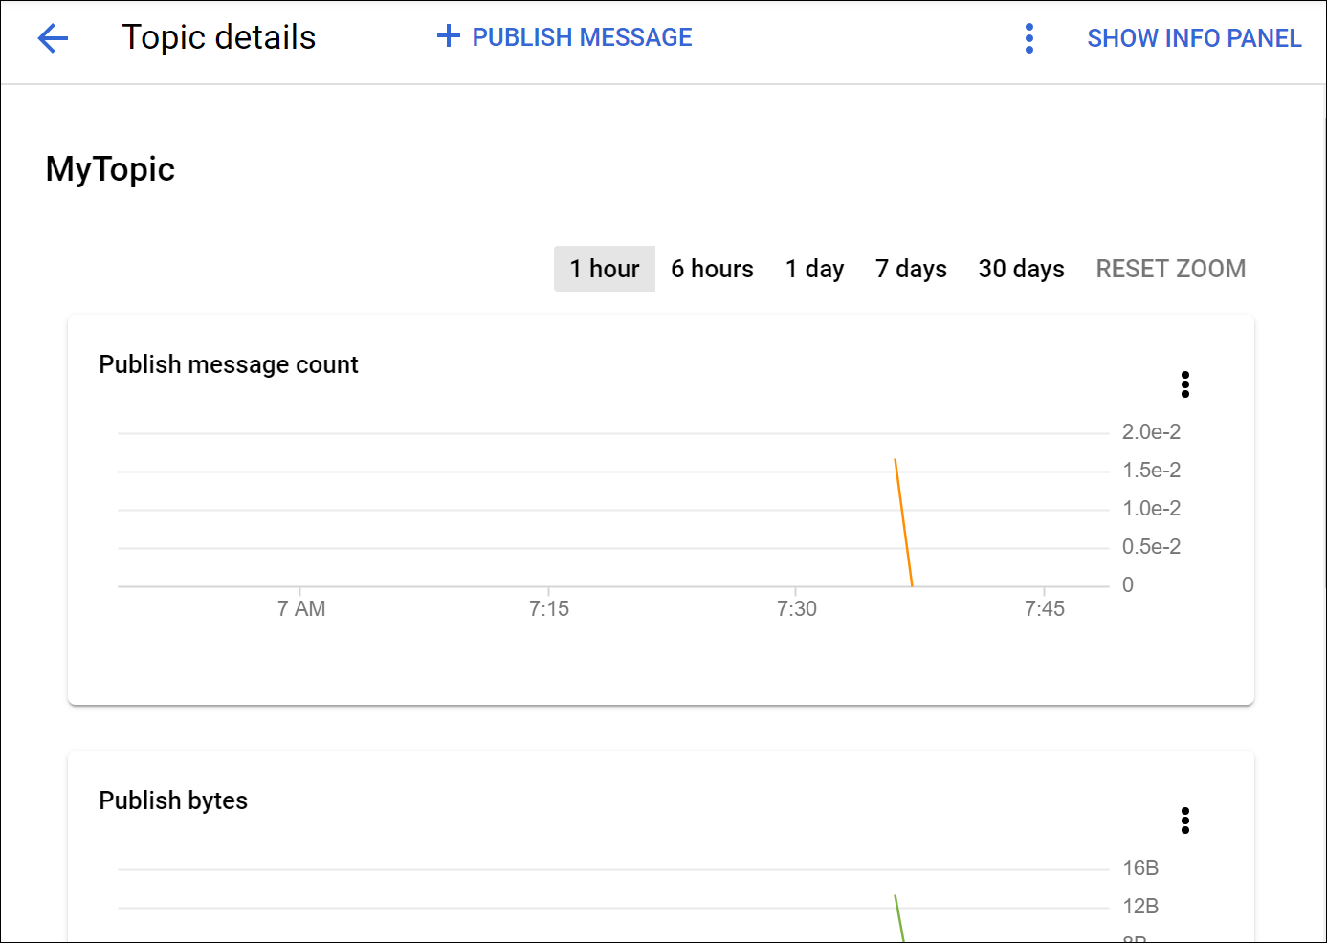

Test Completed Task

Click **Check my progress** to verify your performed task. If you have successfully created Cloud Pub/Sub topic, you will see an assessment score.

Create a Pub/Sub topic.

Check my progress

**Add a subscription**

Now you'll make a subscription to access the topic.

1. Click **Topics** in the left panel to return to the **Topics** dialog. For the topic you just made click the three dot icon > **Create subscription**.

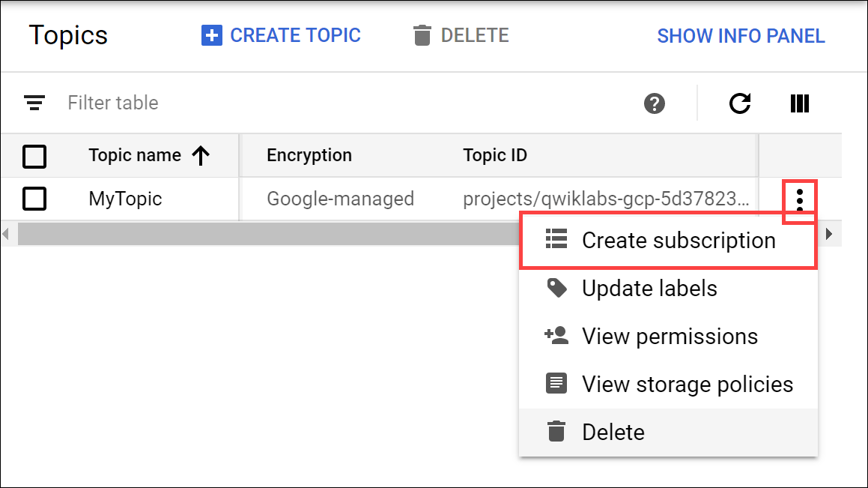

1. In the **Add subscription to topic** dialog:

* Type a name for the subscription, such as **MySub**
* Set the Delivery Type to **Pull**.
* Leave all other options at the default values.
* Click **Create**.

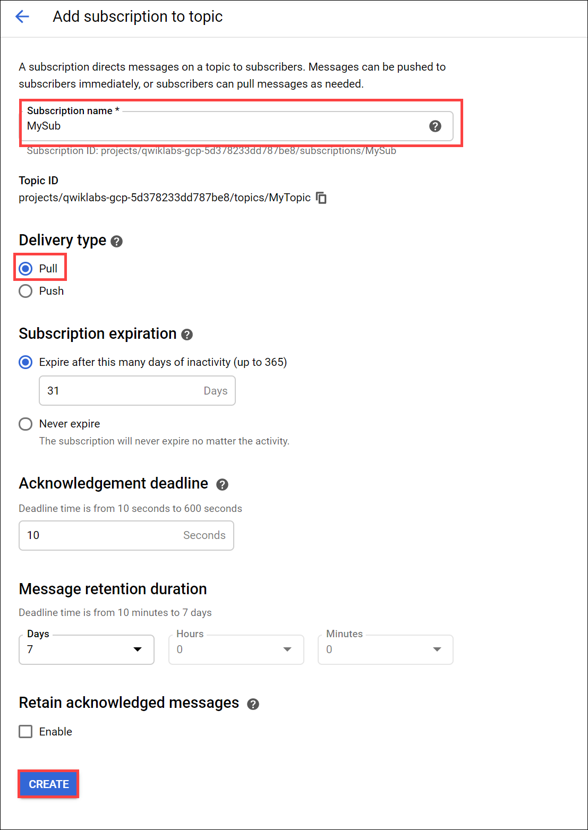

Your subscription is listed in the Subscription list.

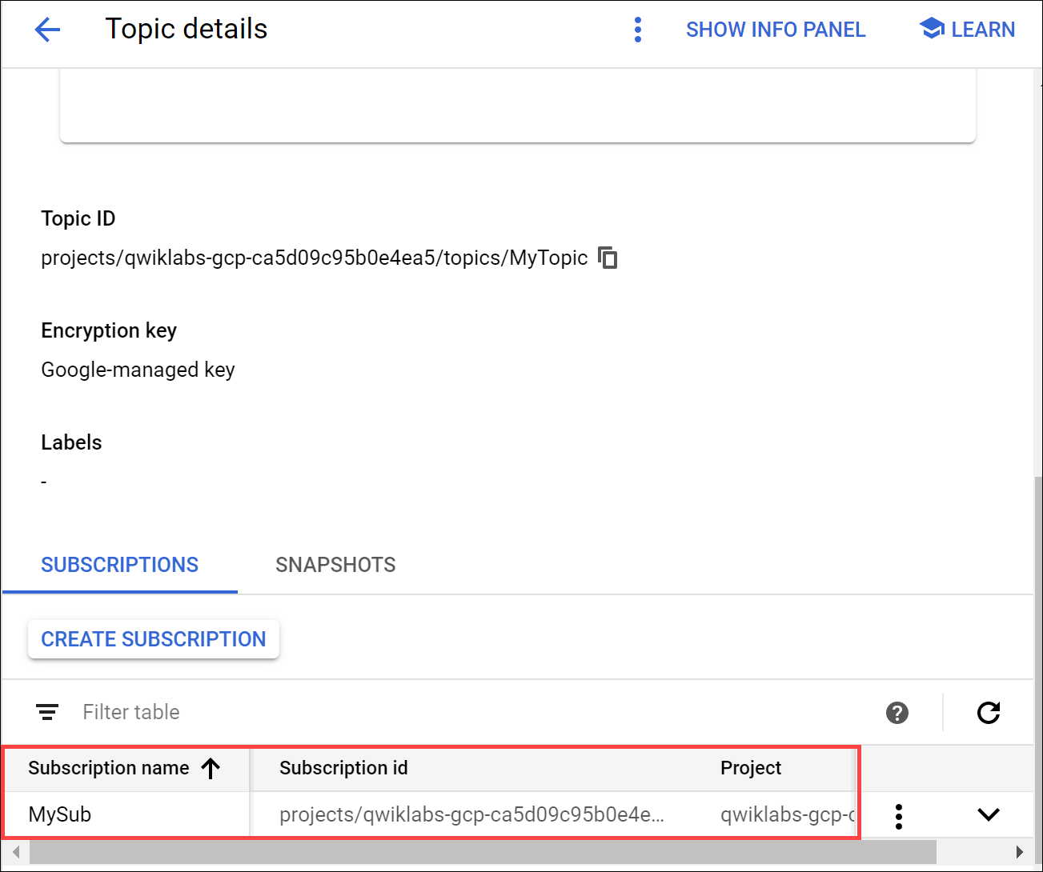

Test Completed Task

Click **Check my progress** to verify your performed task. If you have successfully created subscription for Cloud Pub/Sub topic, you will see an assessment score.

Add a subscription.

Check my progress

**Test your Understanding**

Below are multiple choice questions to reinforce your understanding of this lab's concepts. Answer them to the best of your abilities.

A publisher application creates and sends messages to a \_\_\_\_. Subscriber applications create a \_\_\_\_ to a topic to receive messages from it.



subscription, subscription

checktopic, subscription



topic, topic



subscription, topic

Submit

Cloud Pub/Sub is an asynchronous messaging service designed to be highly reliable and scalable.

checkTrue



False

**Publish a message to the topic**

1. At the top of the **Topics details** dialog, click **PUBLISH MESSAGE**. You may have to widen the browser window to see the **PUBLISH MESSAGE** option.

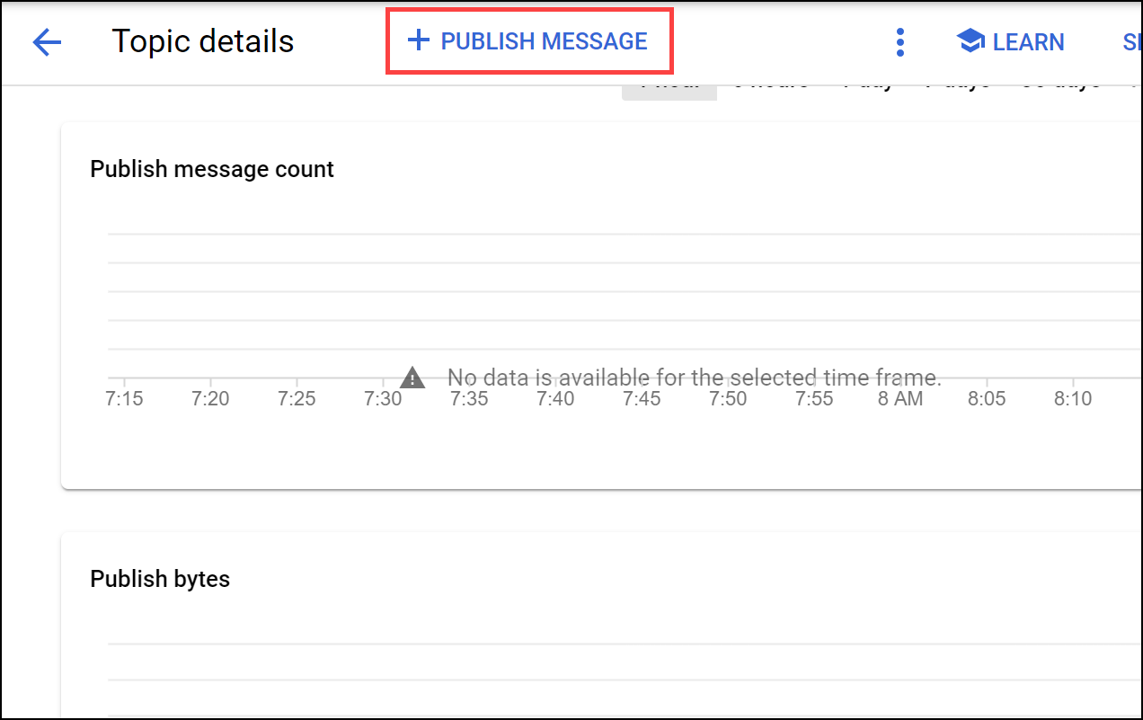

1. Enter Hello World in the **Message** field and click **Publish**.

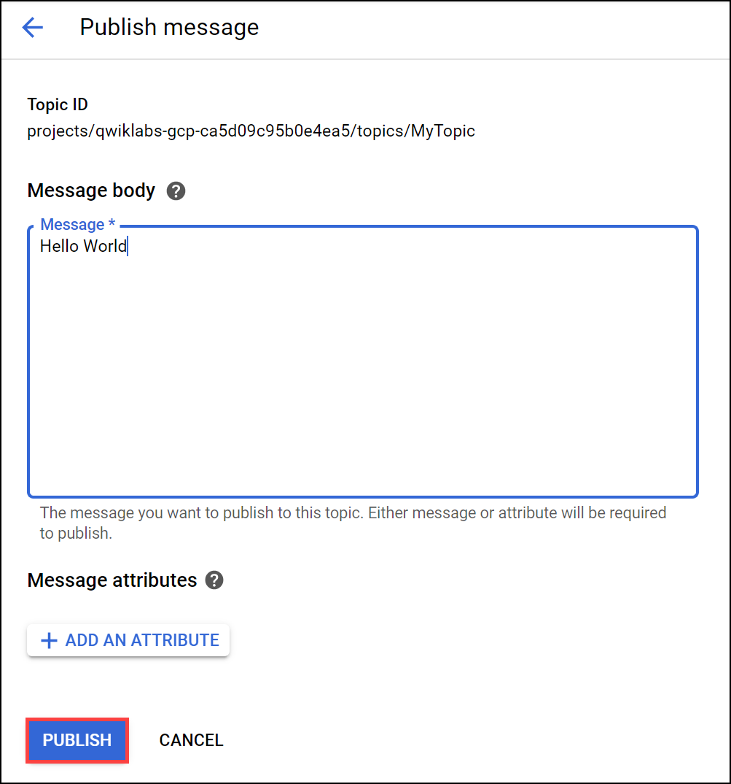

**View the message**

To view the message you'll use the subscription (MySub) to pull the message (Hello World) from the topic (MyTopic).

Enter the following command in command line.

gcloud pubsub subscriptions pull --auto-ack MySub

The message appears in the DATA field of the command output.

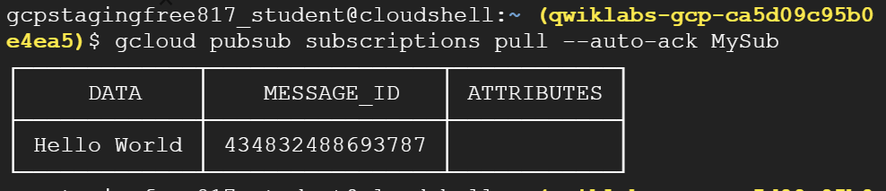

You created a Pub/Sub topic, published to the topic, created a subscription, then used the subscription to pull data from the topic.

**Congratulations!**